---------------SQL SERVER TASK----

Creation and insertion

Joins

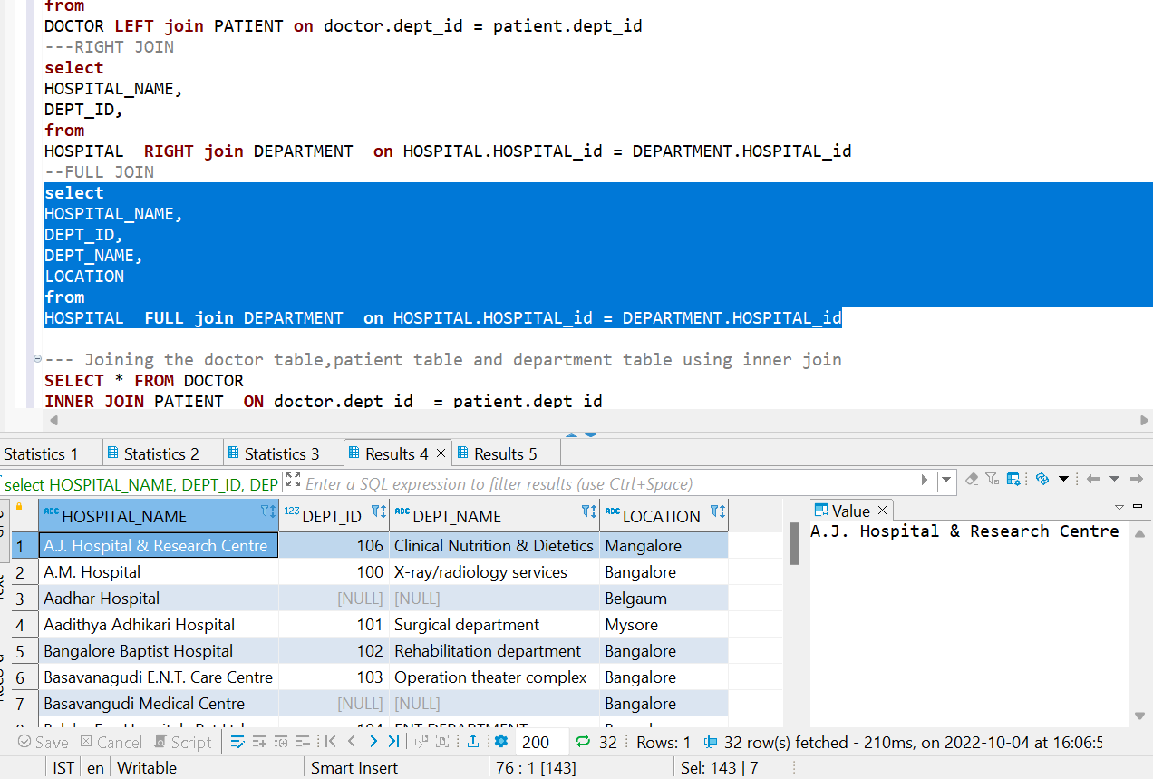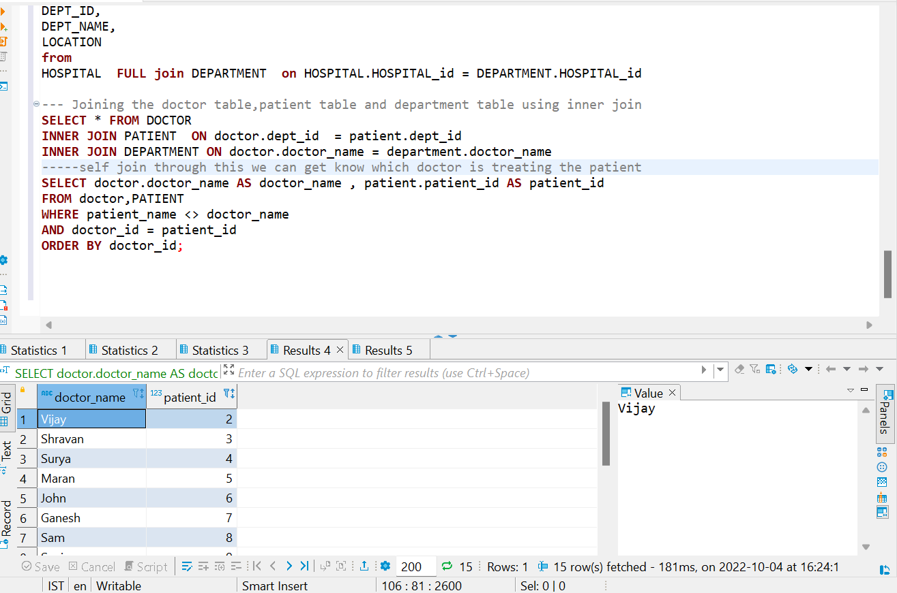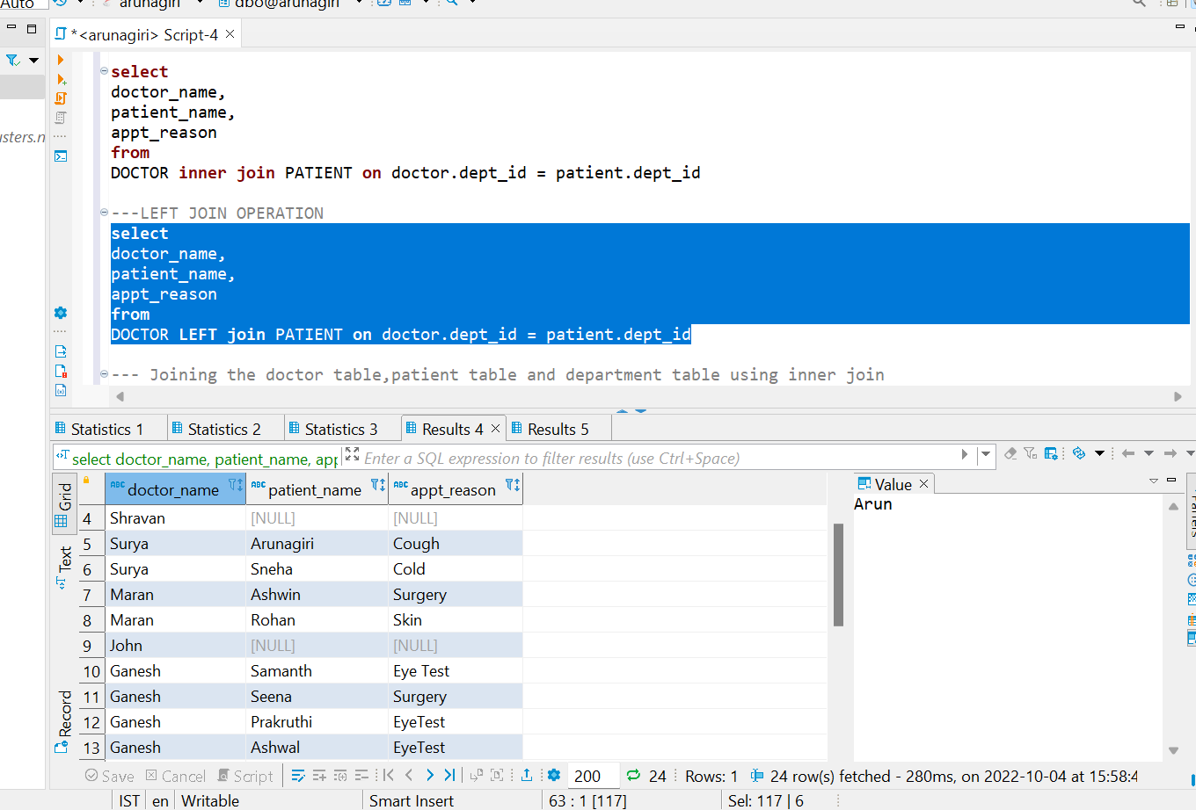

Views

Task 2

**-----CREATION OF SOURCE TABLES USING GIVEN DATA SOURCE**

**CREATE** **TABLE** FA_SALES_2 (

SupplierID **INT**,

SupplierAddress **VARCHAR**(100),

SupplierName **VARCHAR**(100),

SupplierContactDetails **VARCHAR**(100),

ProductID **FLOAT**,

CarMaker **VARCHAR**(100),

CarModel **VARCHAR**(100),

CarColor **VARCHAR**(100),

CarModelYear **INT**,

CarPrice **FLOAT**,

CustomerID **VARCHAR**(100),

CustomerName **VARCHAR**(100),

Gender **VARCHAR**(100),

JobTitle **VARCHAR**(100),

PhoneNumber **VARCHAR**(100),

EmailAddress **VARCHAR**(100),

City **VARCHAR**(100),

Country **VARCHAR**(100),

CountryCode **VARCHAR**(100),

State **VARCHAR**(100),

CustomerAddress **VARCHAR**(100),

OrderDate **INT**,

OrderID **FLOAT**,

ShipDate **INT**,

ShipMode **VARCHAR**(100),

Shipping **VARCHAR**(100),

PostalCode **INT**,

Sales **FLOAT**,

Quantity **INT**,

Discount **VARCHAR**(100),

CreditCardType **VARCHAR**(100),

CreditCard **VARCHAR**(100),

CustomerFeedback **VARCHAR**(100)

)

----DDL OPERATION OF SALES

---CREATE OPERATION--

**CREATE** **TABLE** FA_SALES_2 (

SupplierID **INT**,

SupplierAddress **VARCHAR**(100),

SupplierName **VARCHAR**(100),

SupplierContactDetails **VARCHAR**(100),

ProductID **FLOAT**,

CarMaker **VARCHAR**(100),

CarModel **VARCHAR**(100),

CarColor **VARCHAR**(100),

CarModelYear **INT**,

CarPrice **FLOAT**,

CustomerID **VARCHAR**(100),

CustomerName **VARCHAR**(100),

Gender **VARCHAR**(100),

JobTitle **VARCHAR**(100),

PhoneNumber **VARCHAR**(100),

EmailAddress **VARCHAR**(100),

City **VARCHAR**(100),

Country **VARCHAR**(100),

CountryCode **VARCHAR**(100),

State **VARCHAR**(100),

CustomerAddress **VARCHAR**(100),

OrderDate **INT**,

OrderID **FLOAT**,

ShipDate **INT**,

ShipMode **VARCHAR**(100),

Shipping **VARCHAR**(100),

PostalCode **INT**,

Sales **FLOAT**,

Quantity **INT**,

Discount **VARCHAR**(100),

CreditCardType **VARCHAR**(100),

CreditCard **VARCHAR**(100),

CustomerFeedback **VARCHAR**(100)

)

**SELECT** * **FROM** FA_SALES_2

**select** * **from** FA_INSURANCE

---DML OPERATION

**INSERT** **INTO** FA_SALES_2 **VALUES** (559,'9087 Bonner dro','Trupe',471-08-6486,8876.0,'Infiniti','Q','Orange',2001,757878.29,63187-087,'Eveleen Rittelmeyer','Female' ,'Professor',602-153-9389,'erittelmeyerfd@hao123.com','Phoenix','United States','US','Arizona','1 Independence Circle',43483.0,54868-4381,43624.0,'First Class','Truck',21265.0,779769.27,1,0.58,'jcb',3553500000000000,'Good')

--ddl alter operation

**alter** **table** FA_SALES_2 **alter** **column** customerfeedback **varchar**(200)---increasing the datatype length

--update operation

**update** FA_SALES_2 **set** Suppliername ='arun' **where** supplierid=1

**select**\***from** FA_INSURANCE

**select**\***from** FA_INSURANCE **where** CATEGORY_NAME = 'NEPHROLOGY' ;--SELECTING PARTICULAR DEPARTMENT

**select**\***from** FA_INSURANCE **where** CLAIM_AMOUNT>=29000;---CHECKING CLAIM AMOUNT GRETER THAN OR EQUAL TO 29000

**select**\***from** FA_INSURANCE **where** CLAIM_AMOUNT<=9000;---CHECKING CLAIM AMOUNT GRETER THAN OR EQUAL TO 9000

**select**\***from** FA_INSURANCE **where** CLAIM_AMOUNT!=9000;--CHECKING CLAIM AMOUNT NOT EQUAL TO 9000

**select**\***from** FA_INSURANCE **where** CLAIM_AMOUN<>12008; --NOT EQUAL TO OPERATION

----NULL OPERATIONS

**select**\***from** FA_INSURANCE **where** CATEGORY_CODE **IS** **NULL**

**select**\***from** FA_INSURANCE **where** CATEGORY_CODE **IS** **NOT** **NULL**

**select**\***from** FA_INSURANCE **where** CATEGORY_CODE **IS** **NULL** **OR** AGE **IS** **NULL**

**select**\***from** FA_INSURANCE **where** AGE **IS** **NULL** **OR** CATEGORY_CODE **IS** **NOT** **NULL**

**select**\***from** FA_INSURANCE **where** CASTE_NAME **IS** **NULL** **AND** CATEGORY_NAME **IS** **NULL**

-----IN AND NOT IN OPERATIONS

**select**\***from** FA_INSURANCE **where** CATEGORY_CODE **IN**('M6','M5')

**select**\***from** FA_INSURANCE **where** CATEGORY_CODE **NOT** **IN**(101,201,130,140)

----LIKE OPERATION

**select**\***from** FA_INSURANCE **where** HOSP_DISTRICT **LIKE** '%A%'**AND** MANDAL_NAME **LIKE** 'V%'

**select**\***from** FA_INSURANCE **where** MANDAL_NAME **NOT** **LIKE** '%A'

---BETWEEN OPERATION

**select**\***from** FA_INSURANCE **where** AGE **BETWEEN** 45 **AND** 57

**select**\***from** FA_INSURANCE **where** PREAUTH_DATE **not** **like** '%.'

----DISTINCT OPERATION--

**select** **DISTINCT** DISTRICT_NAME **from** FA_INSURANCE

-----UPPER,LOWER,TRIM AND STRING OPERATIONS

**select** **UPPER**(SupplierName) **AS** SUP_NAME,**LOWER**(SupplierAddress)**AS** SUP_ADDRESS,LEN(SupplierContactDetails) **AS** LEN

**from** FA_SALES_2

**select** **rtrim**(SupplierName) **AS** RTRIMO **from** FA_SALES_2 E---TRIMS THE EXTRA SPACES IN RIGHT SIDE

**select** **ltrim**(SUPPLIERNAME) **from** FA_SALES_2 E

**select** **replace**('arunagiri','giri','@') **from** FA_SALES_2 E

**select** **SUBSTRING**('Arunagiri',1,5) **from** FA_SALES_2 E

**select** **SUBSTRING**('arunagiri@307gmail.com',charindex('@','arunagiri@307gmail.com')+1,len('arunagiri@307gmail.com')) **from** FA_SALES_2 E

**select** **CONCAT**('arun','a','giri') FA_SALES_2 E--CONCATES TWO WORDS

------CASE OPERATION

**select** **case** **when** City <='Anchorage' **then** 'Truck'

**when** City ='Saint Cloud' **then** 'Air'

**else** 'others'

**end** **as** dname **from** FA_SALES_2

**SUM** --- ADDITION OF INTERGER NUMBER

**AVG** ---SUM DIVIEDE NUMBER OF ELEMENTS

**MIN** ---LOWEST VALUE OF THE DATA

**MAX** ---HIGHEST VALUES OF THE DATA

**COUNT** ---NUMBER OF ELEMENTS

---SQL query with all clause .

**select** **sum**(CLAIM_AMOUNT) **as** sum_claim **from** FA_INSURANCE;

**select** **avg**(CLAIM_AMOUNT) **from** FA_INSURANCE;

**select** **min**(CLAIM_AMOUNT) **as** **min**,**max**(CLAIM_AMOUNT) **as** **max** **from** FA_INSURANCE;

**select** **count**(*) **from** FA_INSURANCE;

**select** **count**(3) **from** FA_INSURANCE;

**select** **count**(1)CATEGORY_CODE **from** FA_INSURANCE

**group** **by** CATEGORY_CODE

**HAVING** **COUNT**(1)>1;

----all clause function

**SELECT** **COUNT**(1),CLAIM_AMOUNT

**FROM** FA_INSURANCE

**WHERE** HOSP_NAME **IS** **NOT** **NULL**

**GROUP** **BY** CLAIM_AMOUNT

**HAVING** **COUNT**(1)>2

**ORDER** **BY** CLAIM_AMOUNT **ASC**;

----Rank functions-------

---scenario to check which hospital is having highest claim amount using rank

**SELECT** **RANK** () **OVER** (**PARTITION** **BY** HOSP_NAME **ORDER** **BY** CLAIM_AMOUNT **DESC**) **AS** DRNK,HOSP_NAME,CLAIM_AMOUNT

**FROM** fa_insurance

---CHECHKING DENSE RANK

**SELECT** * **FROM** (

**SELECT** **DENSE_RANK** () **OVER** (**PARTITION** **BY** PID **ORDER** **BY** CLAIM_AMOUNT **DESC**) **AS** DRNK,PID,CLAIM_AMOUNT

**FROM** fa_insurance

**WHERE** PID = 454

)X

**WHERE** drnk = 1;

---ROW NUMBER

**SELECT** **ROW_NUMBER** () **OVER** (**PARTITION** **BY** HOSP_NAME **ORDER** **BY** CLAIM_AMOUNT **DESC**) **AS** ROWNUMBER,HOSP_NAME,CLAIM_AMOUNT

**FROM** fa_insurance

**DROP** **TABLE** Incurance_Claim_State_Healths

**TRUNCATE** **TABLE** Incurance_Claim_State_Health

**DELETE** CarSalesShipment_FA **WHERE** SUPPLIERID = **NULL**